Lab 16: Rotational Inertia

Group Submission
Yoaneli Ortiz, Trung Vo, Patrick Ignaut, Marjory Cevallos, Madelyn Woodrow

PHYS 1401
College Physics -1

3/31/2025

TABLE OF CONTENTS

Objective 3
Equipment 3
Theory and Equations 3
Procedure 4
Data and Observations 5
Calculations 8
Results 11
Sources of Error 12
Discussion 12
Conclusion 13

OBJECTIVE:
The purpose of this experiment is to measure and find the moments of inertia for a disk, ring (thick shell cylinder), and point masses. Then compare their theoretical values against their recorded values during the experiment.

EQUIPMENT:
Meter stick | Rotary Motion Sensor | Large Rod Base | Triple beam balance
Rotational Accessory | Vernier Calipers | Clamp-on Pulley | Thread
45cm rod | Mass and hanger set

THEORY AND EQUATIONS:
The rotational inertia of an object is a measure of how hard it is to rotate the object. The purpose of this experiment is to find the rotational inertia of a ring and a disk experimentally, and to verify that these values correspond to the calculated theoretical values.
Theoretically, the rotational inertia, I, of a thick ring about an axis passing through the center is given by:
I = .5 * M_{r} (R₁² + R₂²)
where M_{R} is the mass of the ring, R₁ is the inner radius of the ring, and R₂ is the outer radius of the ring.
The rotational inertia of a disk is given by:
I = ½ M_{D} R_{D}²
where M_{D} is the mass of the disk and R_{D} is the radius of the disk.
To find the rotational inertia of the ring and disk experimentally, a known torque is applied to the ring and disk, and the resulting angular acceleration, α, is measured.
τ = I α
where τ is the torque caused by the weight hanging from the thread wrapped around the three-step pulley of radius, r.
τ = r F
The tension in the string, F, is less than the weight, due to the downward acceleration. Applying Newton's Second Law for the hanging mass, m, yields
F = m ( g – a )
Finally, the linear acceleration, a, is related to the angular acceleration, α, by
a = r α
A known torque is applied to the three-step pulley on the Rotary Motion Sensor, causing a disk and ring to rotate. The resulting angular acceleration is measured using the slope of a graph of angular velocity versus time. The rotational inertia of the disk and ring combination is calculated from the torque and the angular acceleration. The procedure is repeated for the disk alone to find the rotational inertias of the ring and disk separately.
Percent Error: $\% error = \frac{\left|Accepted value - Computed value\right|}{Accepted value }x100(\%)$

PROCEDURE:
16.4 EQUIPMENT SETUP
- Use the large rod base and the 45 cm rod to support the Rotary Motion Sensor. Plug the sensor into the interface.
- Use calipers to measure the radius (r) of the medium size pulley on the clear three-step pulley.
- Cut a piece of thread about 75 cm long. Run the thread through the hole in the medium size pulley. Tie a large knot inside the pulley to keep the thread from pulling through.
- Clamp the black pulley onto the Rotary Motion Sensor. Note how the pulley is clamped at an angle to match the tangent to the clear three-step pulley. It must also be adjusted vertically using the two thumbscrews, to match the height of the clear pulley being used.
- Connect a mass hanger to the end of the thread. Adjust the length so that it doesn't quite hit the table.
- When the thread is wound onto the three-step pulley, make sure the thread winds smoothly with no overlaps. Also, do not place too much thread on the pulley: Only a single layer of thread is wanted, so that the radius stays constant.
- In PASCO Capstone, create a graph of Angular Velocity vs. Time. Set the sample rate to 20 Hz.
16.5 PROCEDURE – RING AND DISK
- Fasten the disk to the shaft of the Rotary Motion Sensor using the thumbscrew. Position the ring on top using the two pins to key it to the disk.
- Hang about 50 g on the mass hanger, and let it fall. With the mass of the hanger, this is the Total Hanging Mass M_{TH}. The pulley will start spinning. Collect a run of angular velocity vs. time data. Record all values in a table.
- Use a linear curve fit to find the angular acceleration.
- Accounting for Friction: Put just enough mass on the thread to make it fall at a constant speed after a starting push. It will only be about a gram so the mass hanger won’t be used. This is called the friction mass, M_{F}, and is subtracted from the Total Hanging Mass, M_{TH}, to obtain the hanging mass, m, to use in further calculations: m = M_{TH} – M_{F}.
- Remove the ring, and repeat the above procedure for just the disk. Use about 15 g, and also find the friction mass.
- Remove the disk and repeat for just the pulley. Use about 1 g, but don't bother with the friction mass, as it will be too small.
16.6 PROCEDURE – POINT MASSES
- Finding the rotational inertia of point masses will be done with two point masses attached to the black rod from the Rotation Accessory, once with the two masses close to the ends of the rod, and again with the two masses close to the center of the rod.
- Using a meter stick, position the brass masses on the black rod as accurately as possible so that their centers of mass are at the same distance from the center of rotation. In the first case, keep the two masses as far apart as they can be on the rod. Attach the black rod to the clear pulley.
- Now repeat the procedure to find the Rotational Inertia as was done earlier for the disk.
- Repeat the procedure with the two masses near the center of the rod.
- The moment of inertia for a point mass is: Σ MR².
- Consider how one would account for the effect of the rod, and include it’s effect in your calculations.

DATA AND OBSERVATION:
Pt 1
When constructing the device the first thing that was debated between the group members was which wheel for the pulley to use. It was between a red metal wheel and a slightly smaller black plastic wheel. Ultimately, the black wheel was picked since it was the same one used in the example pictures.
While constructing the device, with each piece before it was added, a group member would get the mass of each component. Once the mass was documented, the part was given back to the member building the device and added it to the finished product.
When looking at the table, the group had to complete the members and make sure to perform a trial run before each portion of the lab to make sure any human error was decreased and the results could be more accurate. This did help the group create a more accurate documentation since during one portion of the lab, while the trial run was being done the string kept falling off the pulley. After rereading the lab manual it was noticed that there was supposed to be a weight placed into the hanger set. Once the weight was placed in the hanger set, the string finally stayed in place throughout the rest of the lab.
Run 1 measured the angular acceleration and the hanging mass with the pulley, disk, and ring. Since there was a lot of weight this was the part of the lab the group members were most concerned with the string not being able to sustain the weight. Another concern was the knots on the string not being big enough. During the initial trial run, the knot wasn't big enough and it was made bigger in the end. Luckily, even with the added weight from each component, the knot was finally big enough to hold the weight of everything without it being undone or slipping through. Run 2 consisted of obtaining the same measurements but only with the pulley and the disk, so a member took off the ring. Run 3 consisted of obtaining the same measurements but only with the pulley, so the disk was removed.

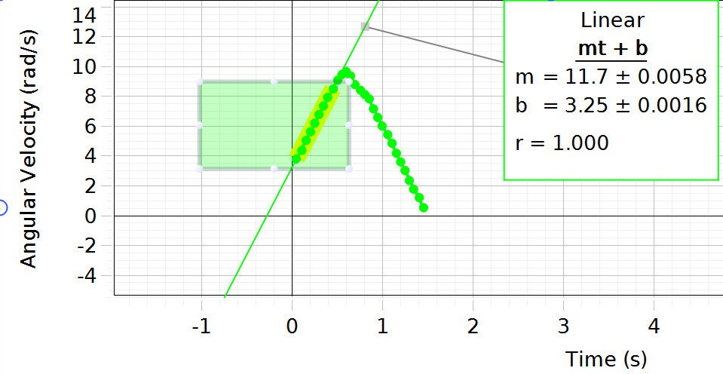
Run 1 Table

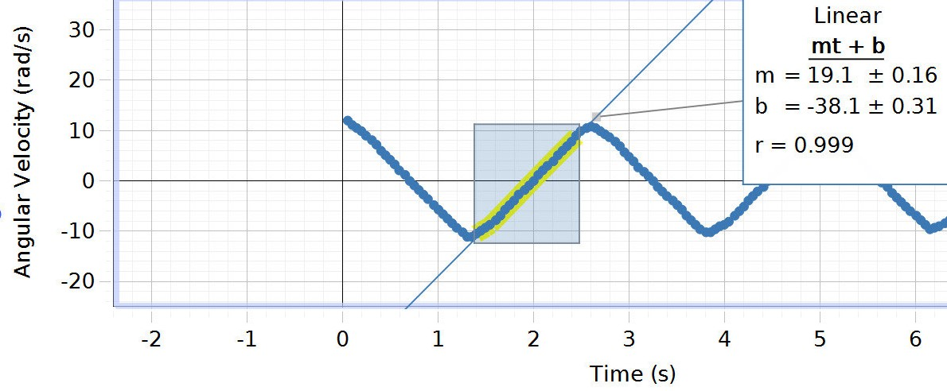
Run 2 Table
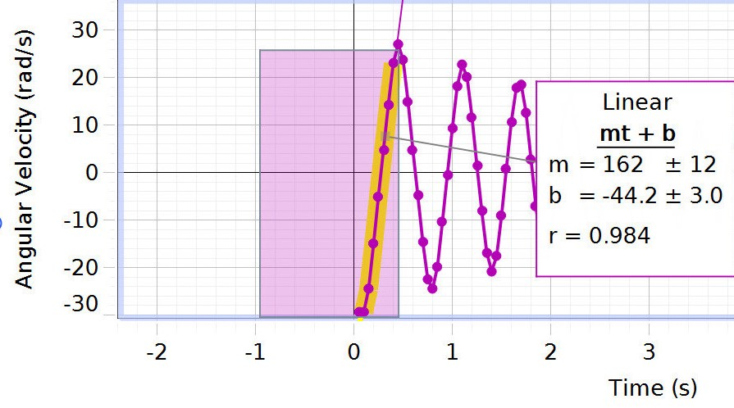
Run 3 Table

Pt 2
During the second portion of the lab, while the trial run was being done, the group ran into an altercation with the rod. The poll kept hitting the wheel from the pulley which would ultimately alter the results. When trying to decrease the angle of the wheel the screw was stuck in place so a group member had to take out his keys to help turn the screw. Finally, the group was able to decrease the angle of the wheel so that the rod wouldn't hit it anymore.
Two masses were placed onto the rod, and two different distances were measured. In the first measurement, the masses were closer to the middle of the rod, and in the second measurement the masses were each at opposite ends of the rod.
After the distance was measured a group member flipped the rotational accessory so the rod could be screwed onto the device. During the lab, the group members noticed that the rod would spin much faster when the masses were close to each other compared to when the masses were farther from each other at each end of the rod.

CALCULATIONS: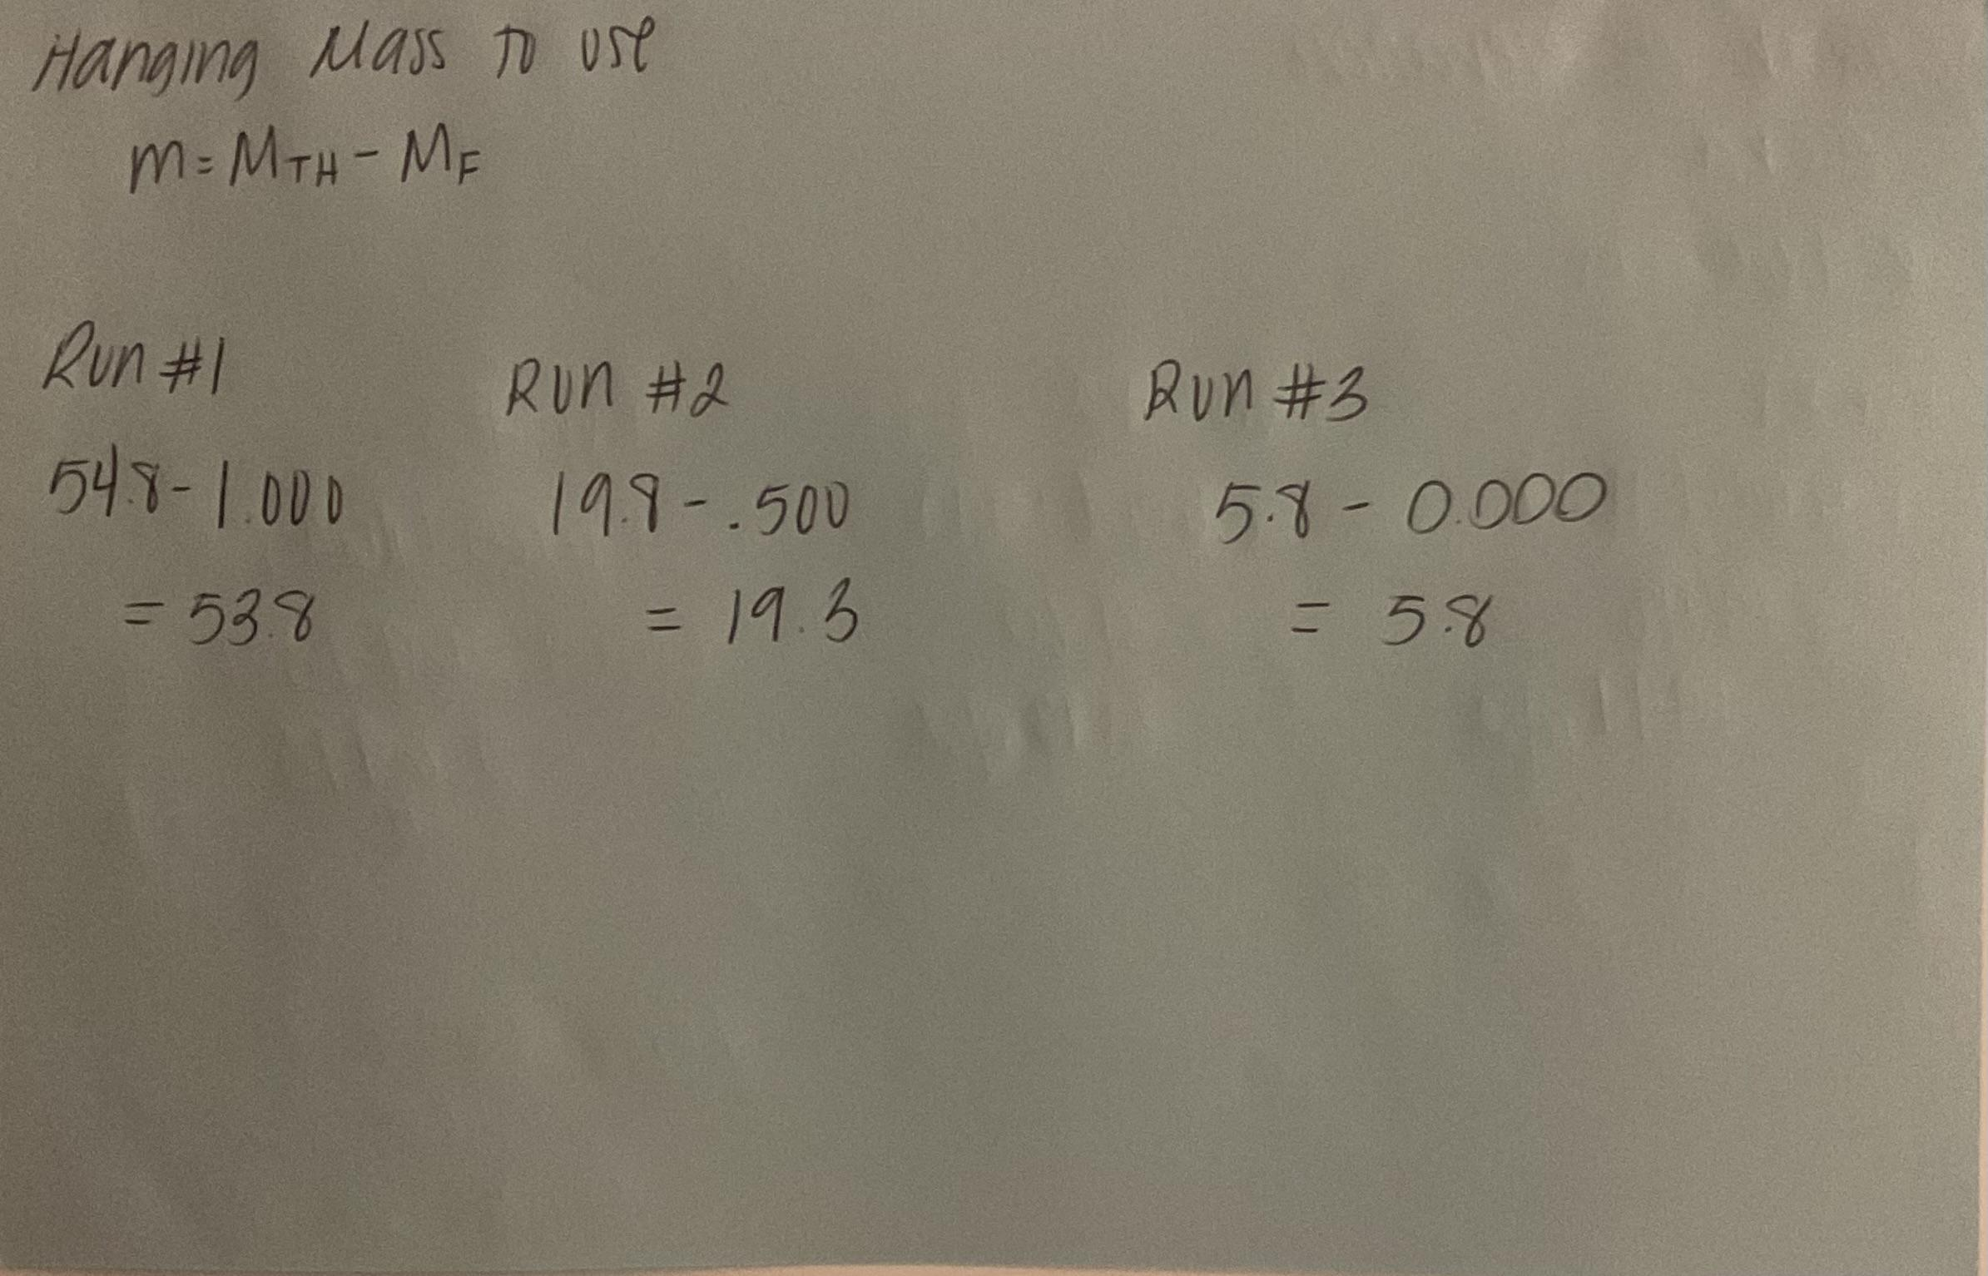
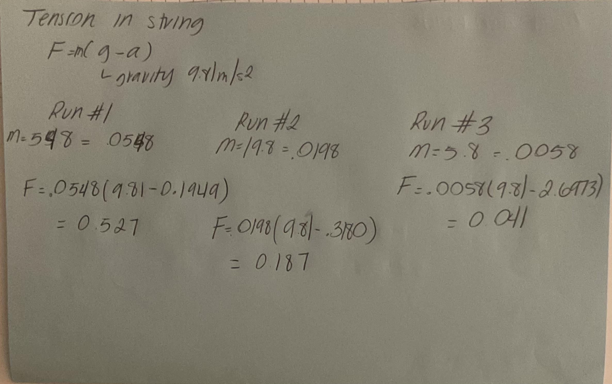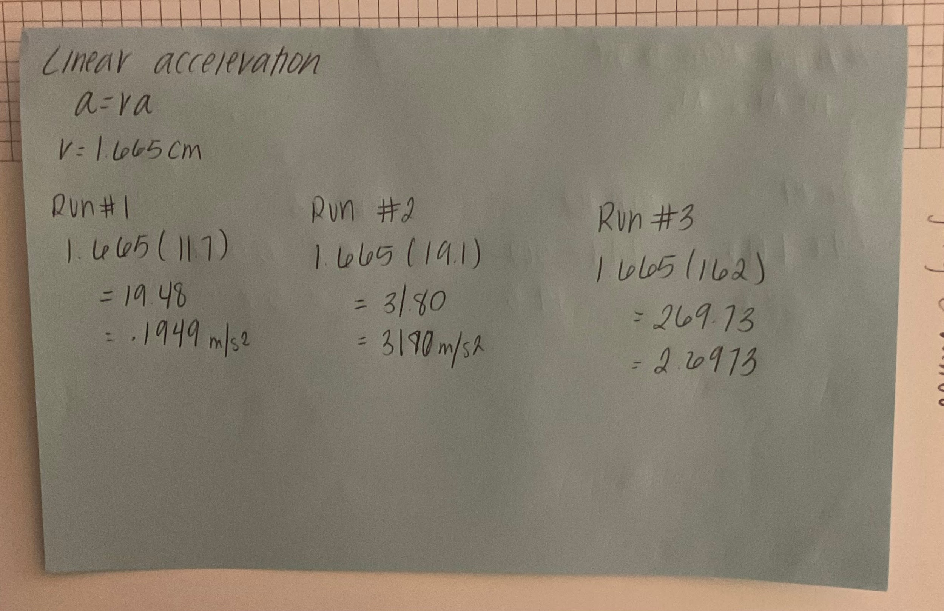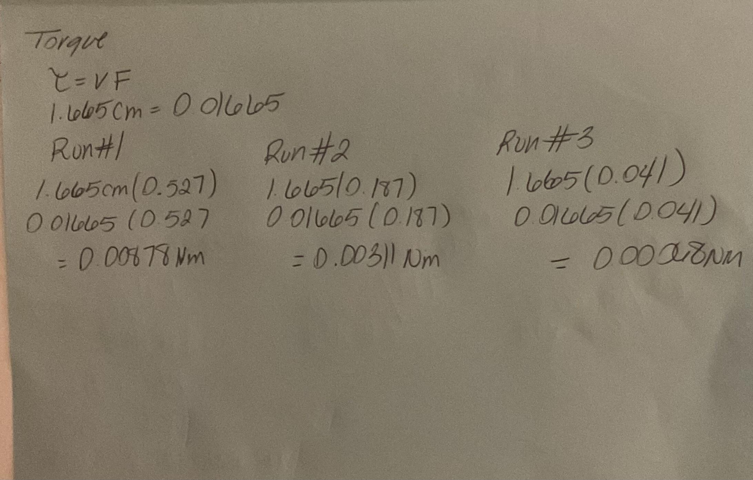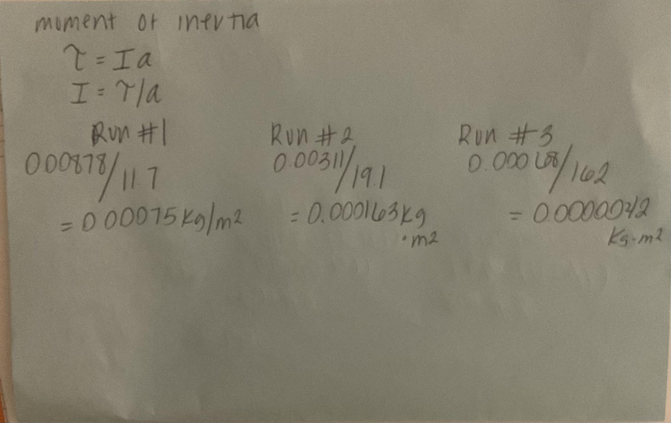
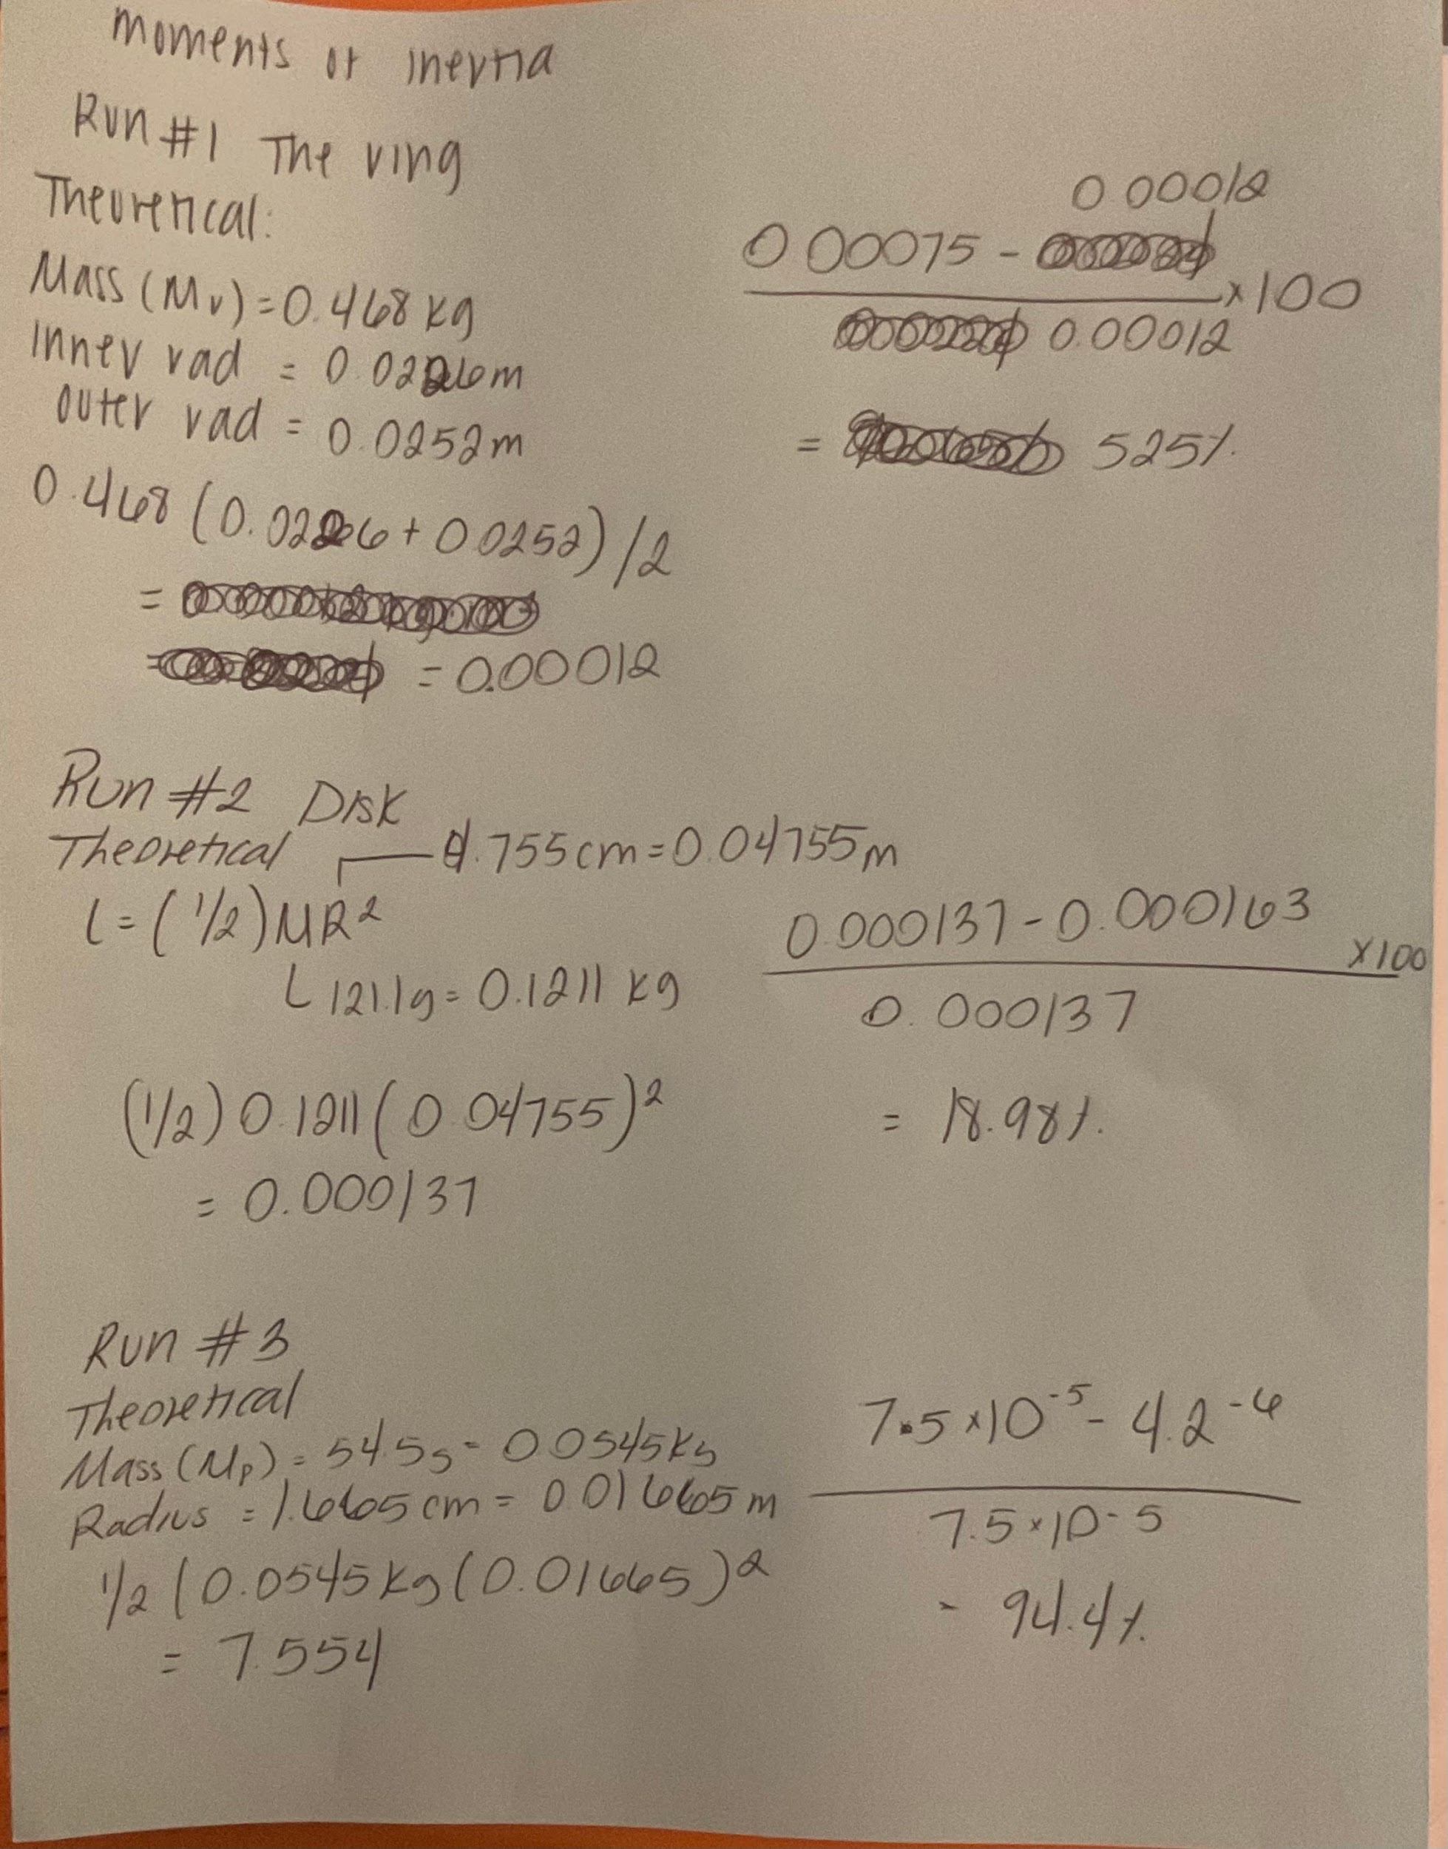

RESULTS:
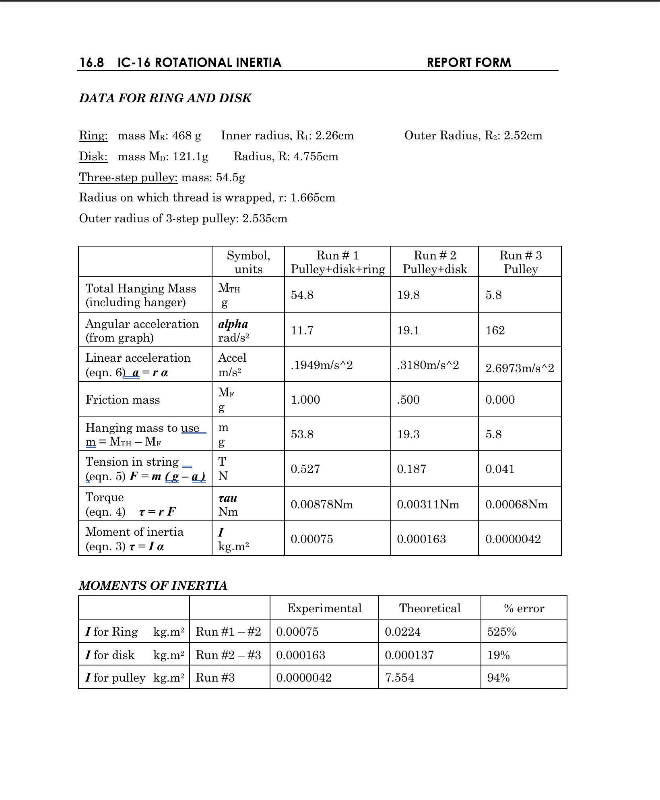

SOURCES OF ERROR:
- The disks were often unstable, and would wobble as a result.
- When the black rod is spinning and the mass hanger is in the way, the experiment is conducted with two point masses attached to its two ends.
- The mass of the string was not accounted for in the experiment which could lead to minor rounding errors.
- The triple beam balance is slightly different from the original point, so the weight results of the items will be slightly inaccurate.
- The point masses would often barely scrape against the disk, which would add additional friction
- There were issues with tying the string to the hanger, which resulted in the string being shorter
DISCUSSION:
In this experiment, theory calculations and real-world measurements were used to find the rotational inertia of a disk, a ring, and a point mass. Each object's moments of inertia were able to be determined and compared to their theoretical values by applying a known torque and measuring the angular acceleration that resulted. The findings revealed some differences between the theoretical and experimental values, which can be explained by air resistance, friction in the rotating motion sensor, and small inaccuracies in the mass and radius measurements. The results that were gathered were quite far off from the theoretical values, this was most likely caused by the amount of error sources that occurred. The equipment used was quite confusing to understand, along with the equipment itself having problems such as the disks being wobbly and the point masses creating extra friction due to occasionally touching the disk. Furthermore, the precision of the angular acceleration measurements might have been impacted by a little misalignment of the thread or pulleys. The experiment successfully illustrated the concepts of rotating inertia and verified the theoretical equations despite these sources of error. Future experiments could be more accurate if improvements like lowering friction, making sure measurements are correct, ensuring proper understanding of the equipment, and repeating trials for consistency are made.
CONCLUSIONS:
The goal of this experiment was to measure and find the moments of inertia for a disk, ring, and point mass, and compare those measured values to their theoretical values. The goal was successfully met by following the procedure. Although the data gathered was far off from the theoretical values given, the moments of inertia were still measured and compared to the theoretical values.

